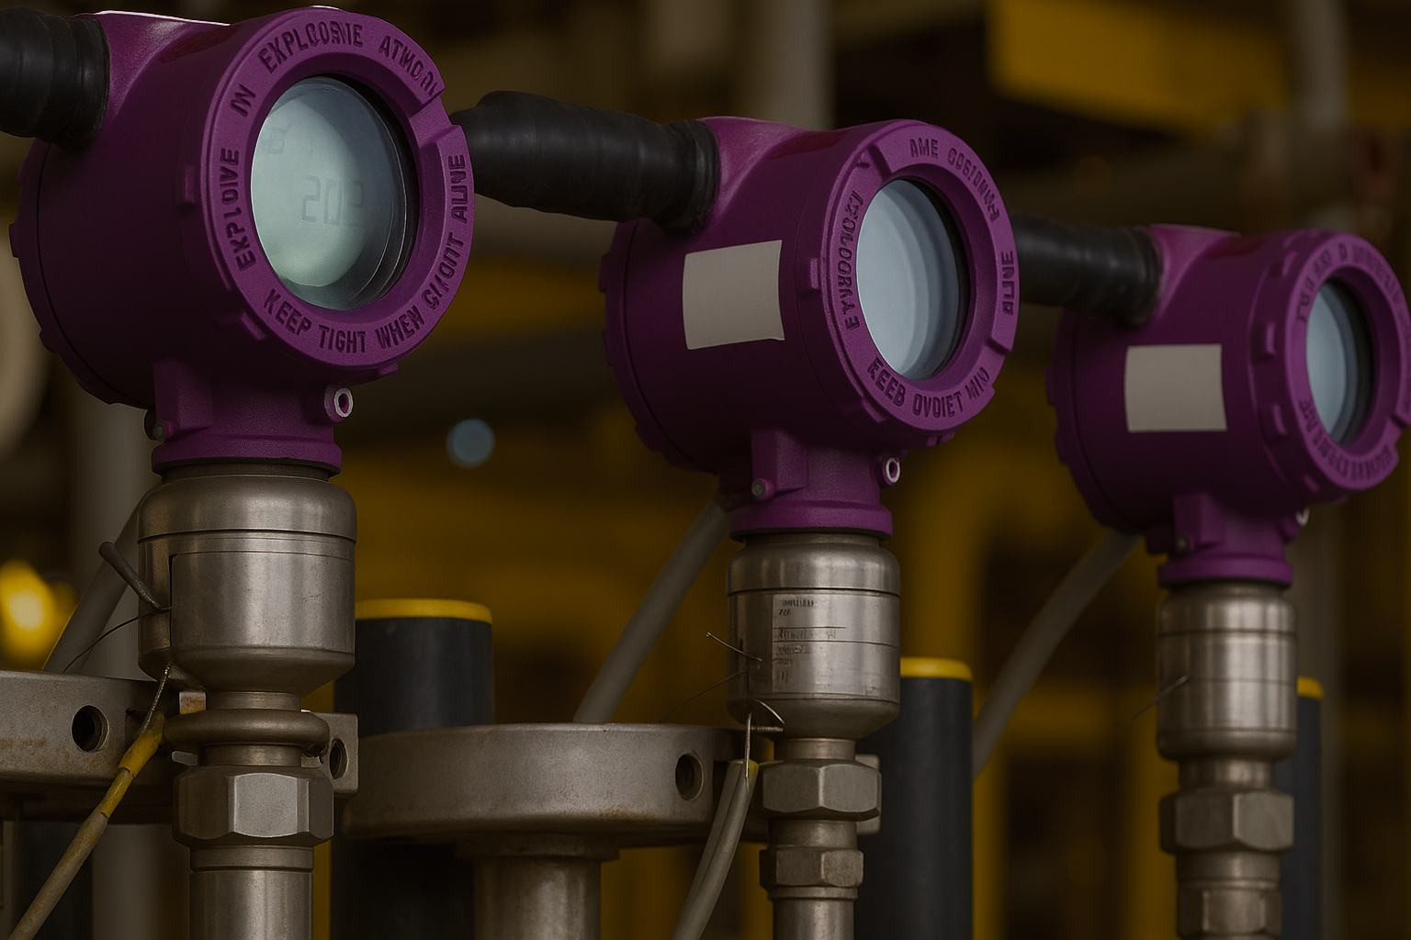

Levtron Instruments Pvt Ltd
Office No 02, 1” Floor, Plot No 6,
Sr. No. 78/1, Pandhari Industrial Estate, Shivane, Pune-411023

9730042725 /9579430012

Sales@levtron.in

1.www.levtron.in
2.www.levtonintruments.com

Ultrasonic level measuring instrument, taking the advantages of various many level measuring instruments, is a universal one characterized by total digitalized and humanized design. It has perfect level monitoring, data transmission and man-machine communication. It is featured by strong anti- interference performance; free setting of upper and lower limits and online output regulation, on-site indication, optional analog, switching value, and RS485 output and easy connection with main unit. The cover, made of waterproof engineering plastics, is small and firm with ABS probe. Therefore, it is applicable for various fields concerning level measuring and monitoring. According to the practical situation, it also can add other modules, such as RS 485, current output; it can be match with PLC better.
LULT-2300L- 5M D 4 N NE NC
Example LULT-2300L-5-D-4-N-NE-NC
Measuring range: 0-5m, power supply 24VDC， Output :4- 20MA ，display No display with No Explosion-proof and No Corrosion-proof
NC：No Corrosion-proof C：Corrosion-proof
Corrosion-proof class
NE：No Explosion-proof EX：Explosion-proof
Explosion-proof class
N：No display E：LED D： LCD
Display
4：4~20MA H：Hart
RS：RS485 AV0:0-5VDC AV2：0-10VDC AV3:1-10VDC
Output signal
A:220V，D:24VDC，D1:12VDC
Supply voltage
1,2,3 10,15,20,30,40(MAX)
Range pressure
LULT-2300L
Product category
Selection table

Technical Parameters
Comprehensive  accuracy | 0.3%F.S
Blind spot | ＜0.4-1.8m（different for range）
Medium | Well water, fire water tank, river water, tap water, etc.
Working temperature | normal temperature, normal pressure
Warranty period | 12 months
Frequency | 20～350KHz
Power supply | 12-24VDC
Output signal | 4～20mA RL>600Ω（standard）,1～5V\1～10V,RS485  2 NPN,2 relays (AC: 5A 250V DC: 10A 24V)
Housing material | ABS
Power consumption | <1.5W
Dimension | Φ92mm×198mm×M60/79mm×300mm×DN80
Sealing class | IP65(others optional)
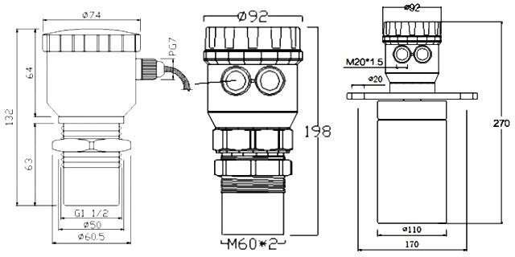
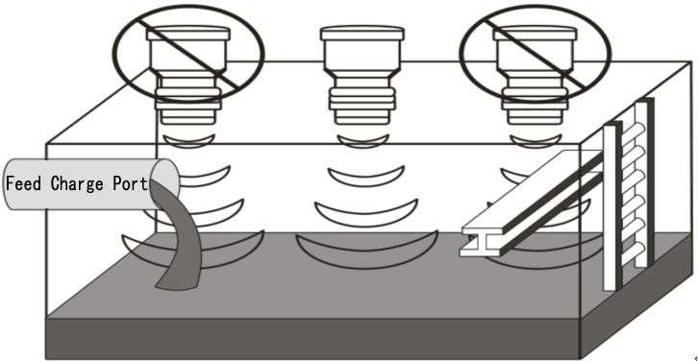
LULT-2300L-B1 LULT-2300L-C1 LULT-2300L-D1

Wiring Diagram

Definition of lead
pin／color
applied
Supply + ⑤DC12~24V+ Yes／□No
Supply -
⑥DC12~24V-
Yes／□No
Current output ⑨4~20mA Yes／□No
Voltage output
□Yes／□No
Serial output ③RS485(A) □Yes／□No
④RS485(B)
Output controlⅠ
①J1_COM
②J1_NO
□Yes／□No

Wiring diagram of current (voltage) output connecting with secondary instrument
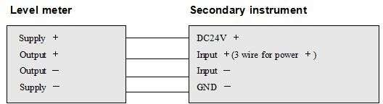
serial output connecting with PC
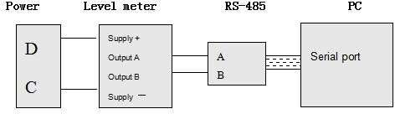
NPN output wiring diagram
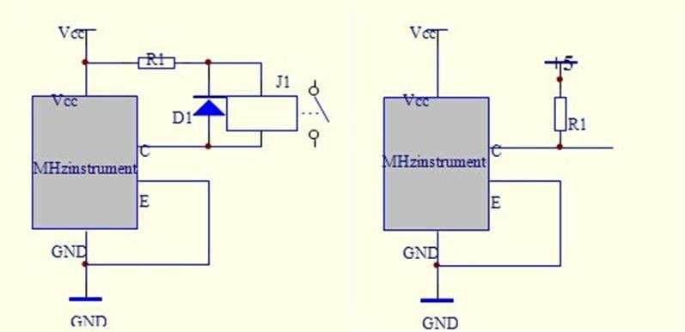
Relay output setting：
This instrument has 2 relays or 3 NPN output. When uses relay control, it must be set control point: D and H. D for relay start point, H for
relay end point. X for display value. It works as follows:
When D﹤H when D﹥H
X﹤D close | D | D<X<H retain | H | X﹥H Disconnect

X﹥D close | D | D>X>H retain | H | X﹤H Disconnect

